Python Script Output
A vs E Data Output
Summary Statistics and Significant Gene Lists
Based on p-value and log2 fold changes there are 1405 significantly downregulated genes and 1392 significantly upregulated genes out of the total 6397 genes in the dataset. The change in expression is dependent on the log2 fold change being above/below 0 (respectively for upregulated and downregulated) and the significance is when the p-value is below 0.05.
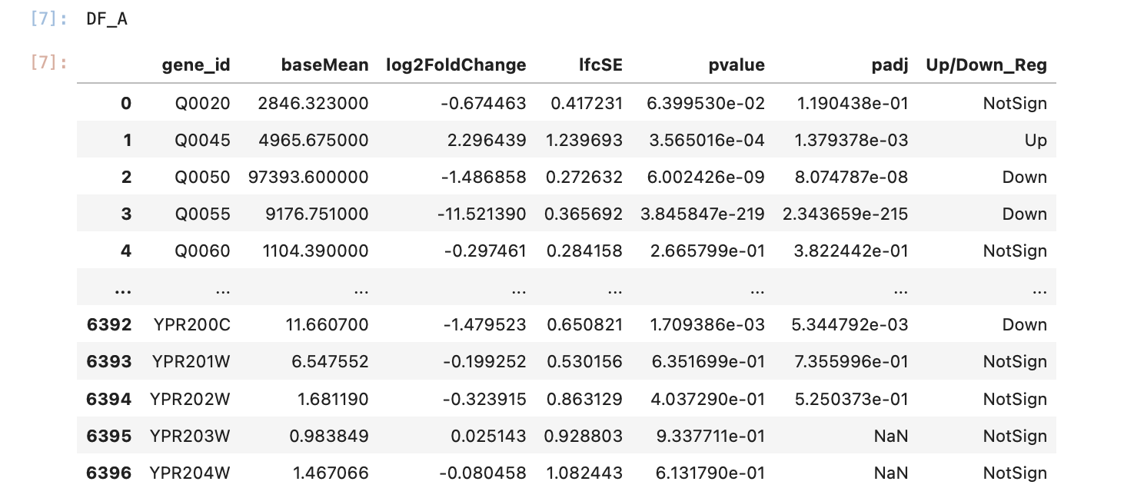

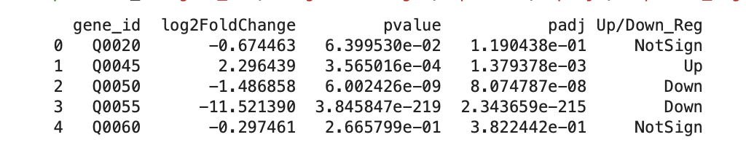
Fig 1a: Image of the A_vs_E.deseq.results.tsv file. The figure shows the addition of a new column labelled ‘Up/Down_Reg’ which indicates if the genes were upregulated, downregulated or if there was no significant change in their expression.

Fig 1b: Image of the A_vs_E.deseq.results.tsv. The figure shows a filtered version of the original data frame. The columns returned are the gene id, the log fold change, adjusted p-value and their regulation.

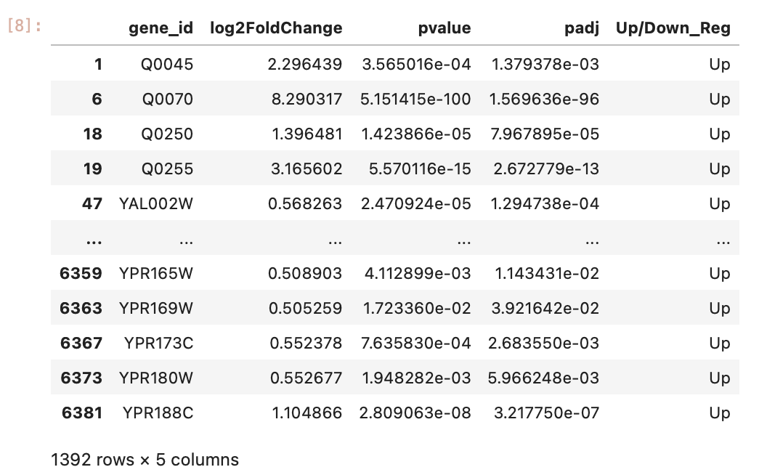

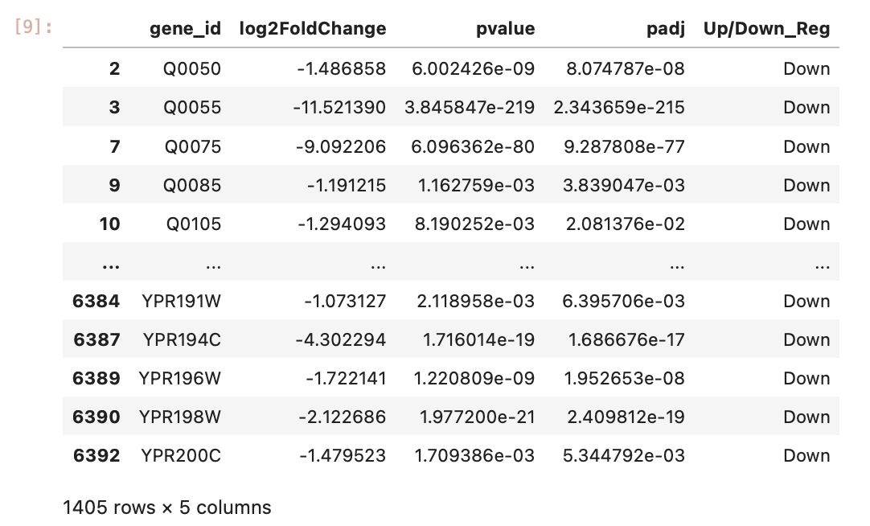
Fig 1c: Image of the A_vs_E.deseq.results.tsv file. The figure shows a filtered version of the original dataframe. The columns returned are the gene id, the log fold change, p-value and adjusted p-value for only the significantly upregulated genes.

Fig 1d: Image of the A_vs_E.deseq.results.tsv file. The figure shows a filtered version of the original dataframe. The columns returned are the gene id, the log fold change, p-value and adjusted p-value for only the significantly downregulated genes.
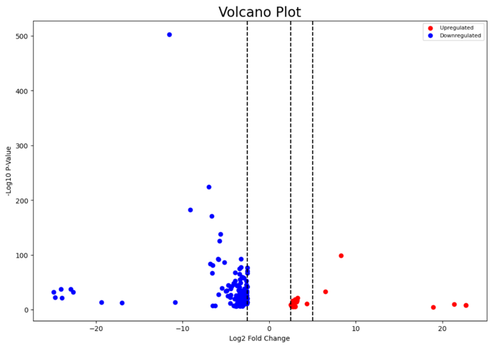
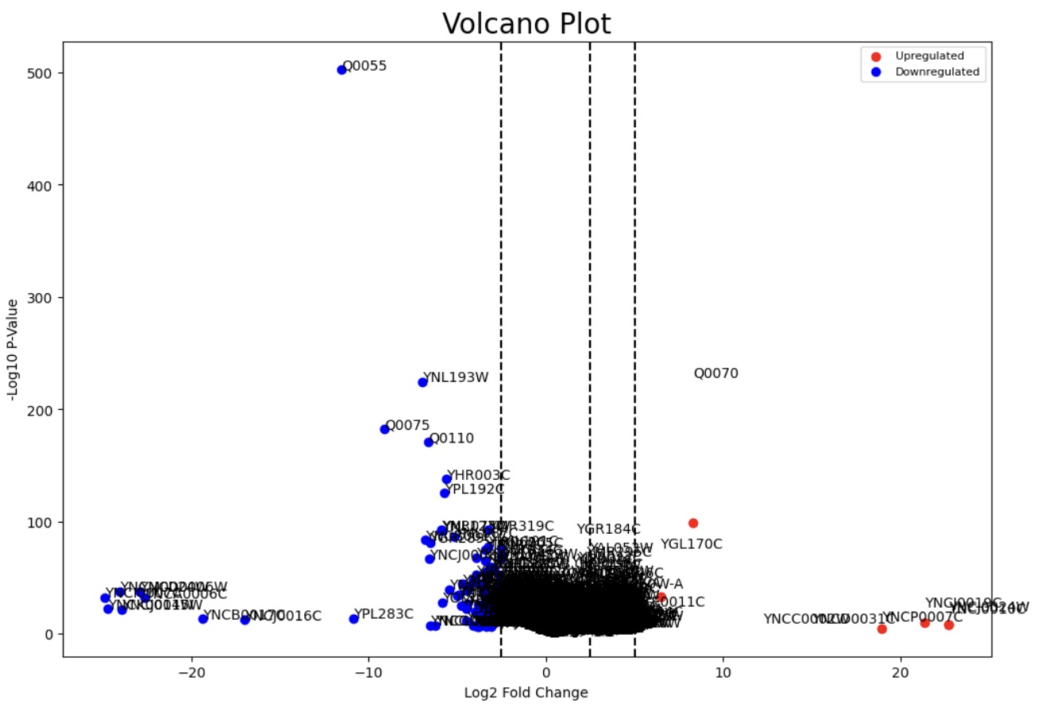
Plots
Fig 2a: Volcano Plot visualising the Significance and magnitude of changes in gene expression for all genes in the A_vs_E.deseq.results.tsv file. Image on the left is annotated with gene names, and image on the right is not annotated for clarity in the plot. Upregulated gene in the plot are red and downregulated genes are blue.

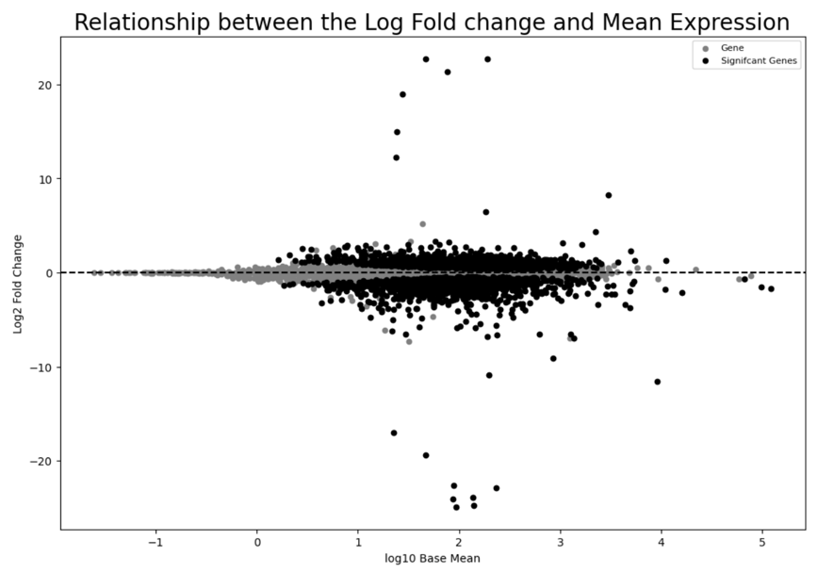

Fig 2b: MA Plot displaying the relationship between the log fold change and mean expression in the A_vs_E.deseq.results.tsv file. Significant genes are displayed in black, and all other genes are grey. Base mean data was used to display mean expression.
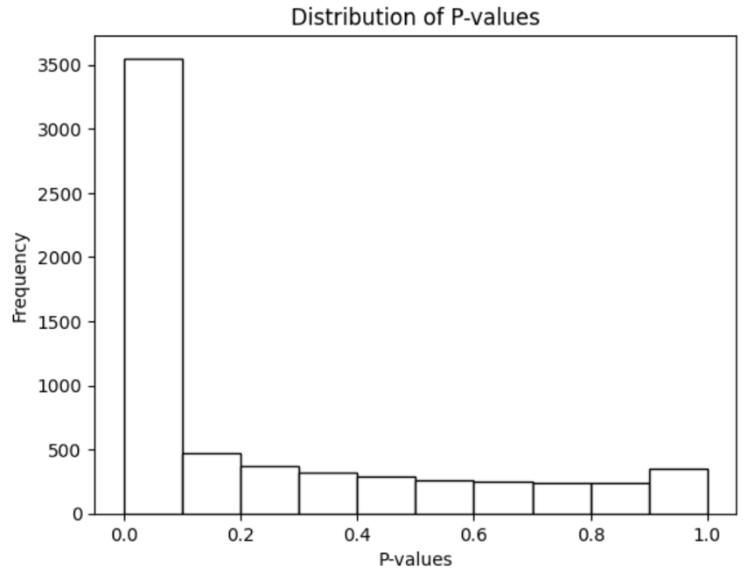

Fig 2b: Histogram Plot of p-values to assess the distribution of statistical significance in the A_vs_E.deseq.results.tsv file.

I vs E Data Output
Summary Statistics and Significant Gene Lists
Based on p-value and log2 fold changes there are 1732 significantly downregulated genes and 1661significantly upregulated genes out of the total 6397 genes in the dataset. The change in expression is dependent on the log2 fold change being above/below 0 (respectively for upregulated and downregulated) and the significance is when the p-value is below 0.05.
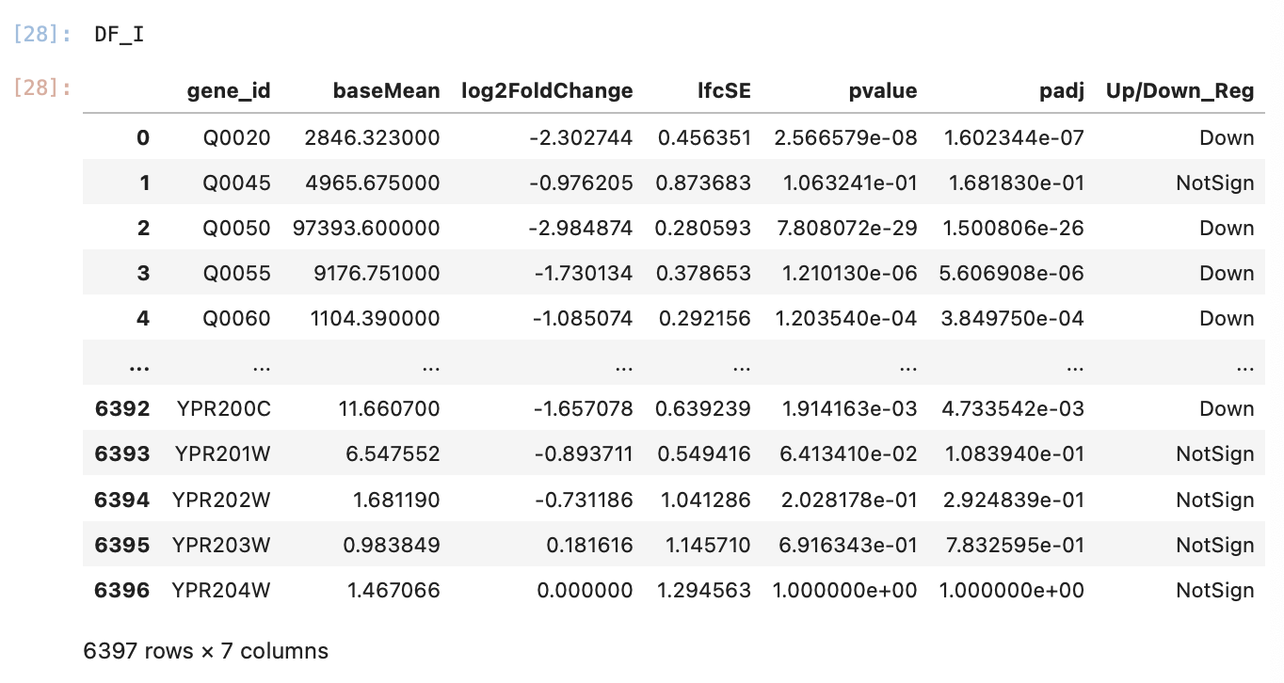

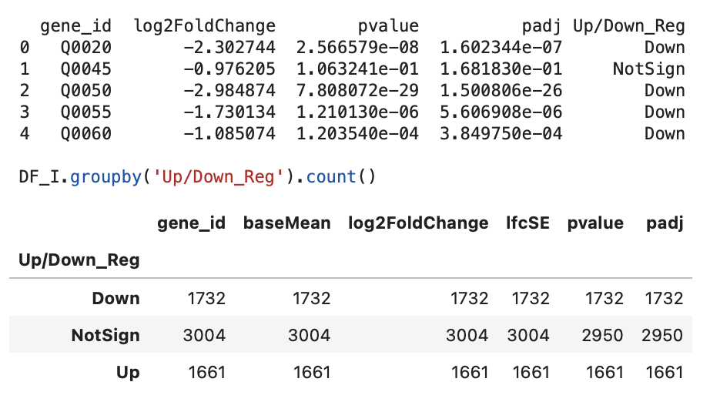
Fig 1a: Image of the I_vs_E.deseq.results.tsv file. The figure shows the addition of a new column labelled Up/Down_Reg which indicates if the genes were upregulated, downregulated or if there was no significant change in their expression.

Fig 1b: Image of the I_vs_E.deseq.results.tsv file. The figure shows a filtered version of the original dataframe. The columns returned are the gene id, the log fold change, p-value, adjusted p-value and their regulation.
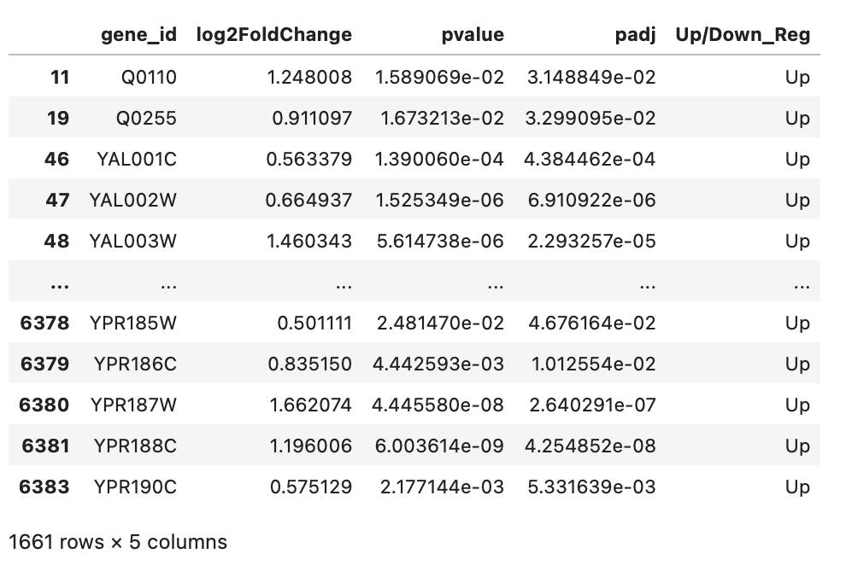

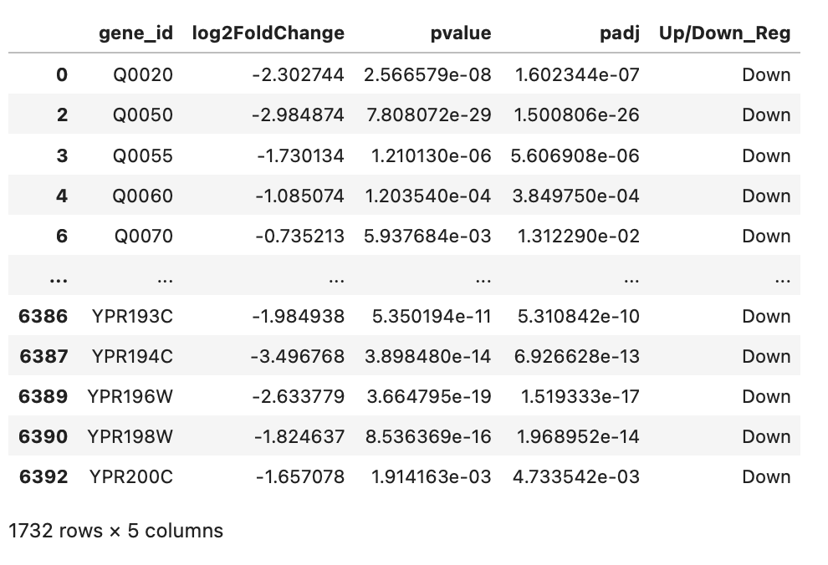
Fig 1c: Image of the I_vs_E.deseq.results.tsv file. The figure shows a filtered version of the original dataframe. The columns returned are the gene id, the log fold change, p-value and adjusted p-value for only the significantly upregulated genes.

Fig 1d: Image of the I_vs_E.deseq.results.tsv file. The figure shows a filtered version of the original dataframe. The columns returned are the gene id, the log fold change, p-value and adjusted p-value for only the significantly downregulated genes.
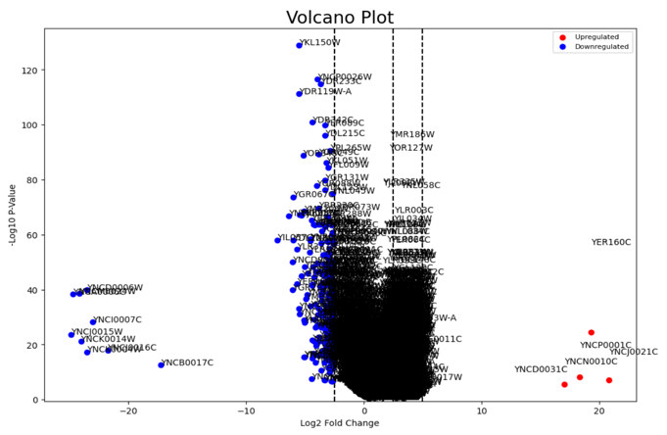
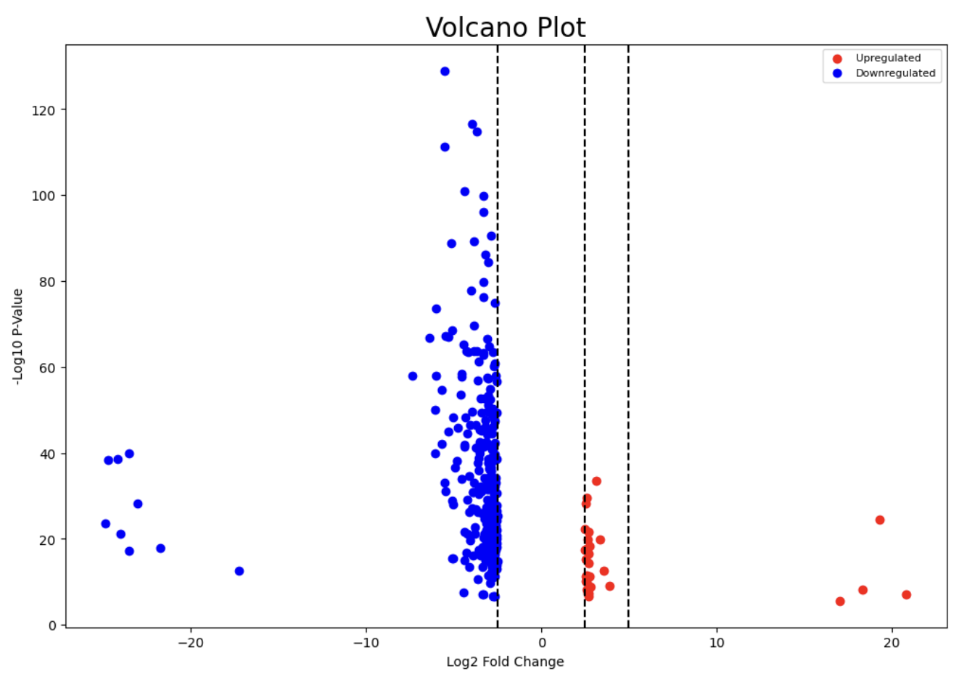
Plots
Fig 2a: Volcano Plot visualising the Significance and magnitude of changes in gene expression for all genes in the I_vs_E.deseq.results.tsv file. Image on the left is annotated with gene names, and image on the right is not annotated for clarity. Upregulated gene in the plot are red and downregulated genes are blue.
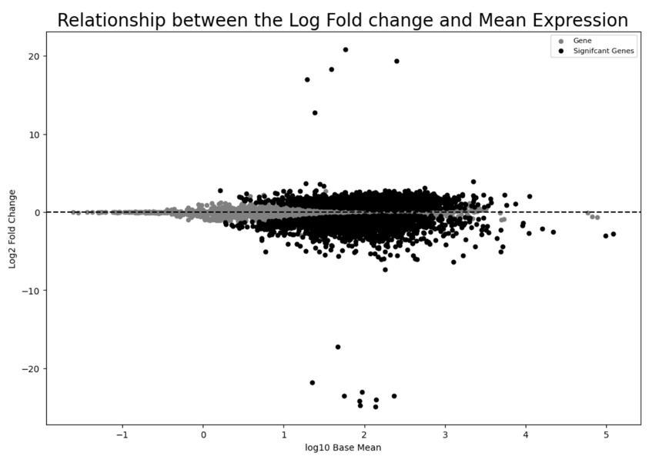

Fig 2b: MA Plot displaying the relationship between the log fold change and mean expression in the I_vs_E.deseq.results.tsv file. Significant genes are displayed in black, and all other genes are grey. Base mean data was used to display mean expression.
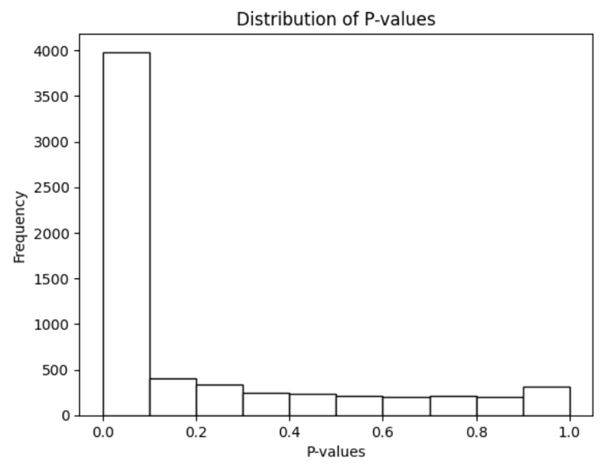

Fig 2b: Histogram Plot of p-values to assess the distribution of statistical significance in the I_vs_E.deseq.results.tsv file.

